Blackberry Sriracha Chicken Sliders
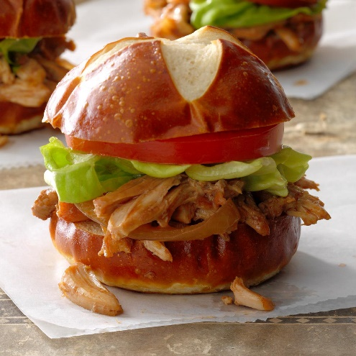
Prep time 20 min Cook time 25 min
12 Sandwiches
Ingredients
10 oz seedless blackberry spreadable fruit
¼ cup ketchup
¼ cup balsamic vinegar
2 tbsp Sriracha chili sauce
2 tbsp molasses
1 tbsp Dijon mustard
¼ tsp salt
3 lb boneless skinless chicken breasts
1 large onion, thinly sliced
4 garlic cloves, minced
12 pretzel mini buns
Leaf lettuce and tomato slices
Directions
- In a mixing bowl, combine the first seven ingredients. Add chicken, onion and garlic. Toss to combine. Place in a baking dish and cook at 350 degrees uncovered for 19 minutes convection oven (25 minutes oven).
- Remove chicken from baking dish. Let cool before shredding.
- Serve on pretzel buns. Drizzle with sriracha and top with lettuce and tomato.
Notes
This can be served over rice instead of on buns.
You can increase the sriracha sauce for more spice.

